FA22-SP23 FYP



**Make your Drive Digital**

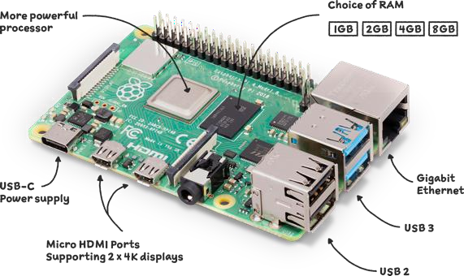 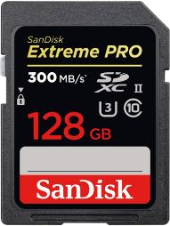 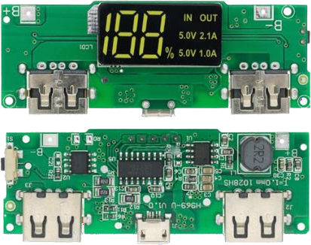

**Raspberry Pi 4 Model B 2019 Quad Core 64 Bit Wi-Fi Bluetooth (4GB)** Dimesnion:3.94 x 2.76 x 1.18 inches

SanDisk 128GB Extreme PRO SDXC UHS-II Memory Card

LED Dual USB 5V 2.4A Micro/Type- C USB Mobile Power Bank 18650 Charging Module Lithium Battery Charger Board Circuit

Dimension: 68 mm x 27mm x 9 mm

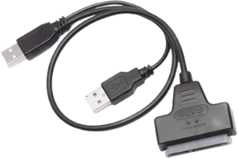 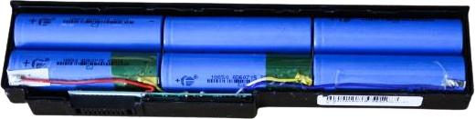 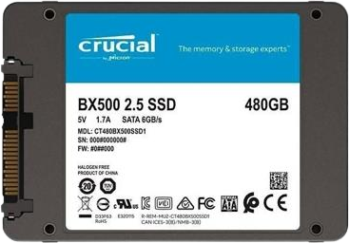

Hard Disk Drive 7+15 Pin SATA to USB 2.0 Adapter Cable for 2.5 Inch HDD Laptop

Dimensions: 6.61 x 5.12 x 0.51 inches

**Battery cell per cell** Dimension:49.2mm length and 13.5mm diameter.

**SSD size**

Dimension: four inches (101 millimeters) in width, 5.75 inches (146 millimeters) in depth and one to 1.63 inches (25 millimeters to 41 millimeters) in height.

ELECROW 5 Inch Raspberry Pi Screen Touchscreen 800x480 TFT LCD Display HDMI Monitor for Raspberry Pi 4B 3B+ 3B 2B+ BB Black Banana Pi Jetson Nano Windows 10 8 7

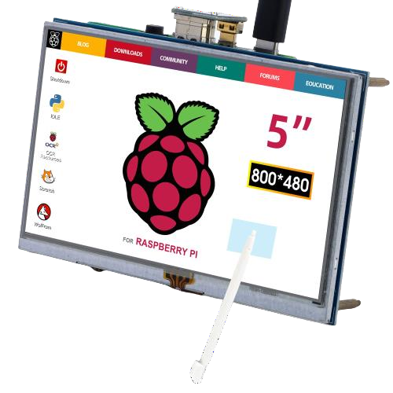

Dimension 4.72 x 2.76 x 0.35 inches